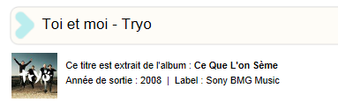
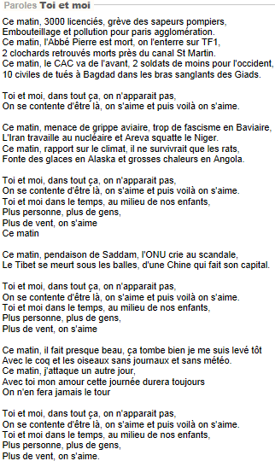

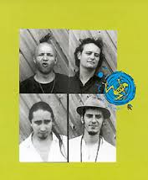
Tryo is a French language 'unplugged' ska acoustic band, popular in Europe and in Quebec, with three French guitarists, a percussionist, and a producer: Guizmo, Christophe Mali, Manu Eveno, Daniel "Danielito" Bravo and Bibou.Tryo are popular in France partly due to their politically charged lyrics, whilst also showing a fun side with a range of humorous songs, especially in live performances. They take a left wing stance, criticising various French politicians such as Charles Pasqua (named in corruption scandals concerning suburban low cost housing or HLM) and Jean-Marie Le Pen and world leaders (George W. Bush, for example) in their music. The band has a "tolerant" view on cannabis, demonstrated by "La Main Verte" from the Mamagubida album. Drug references are reduced in their later albums. They have sold 900,000 albums. They had their 10 year anniversary in 2005, followed by a nationwide tour. Tryo have four studio albums, a double CD live album and two live DVDs.
____________________________________________________________________________________________________________________________________________________________________________________________________________________________________________________________________________________________________________________________________________________________________________________________________________________________________________________________________________________________________________________________________________________________________________________________________________________________________________________________________________________________________________________________________________________________________________________________________________________________________________________________________________________________________________________________________________________________________________________________________________________________________________________________________________________________________________________________________________________________________________________________________________________________________________________________________________________________________________________________________________________________________________________________________________________________________________________________________________________________________________________________________________________________________________________________________________________________________________________________________________________________________________________________________________________________________________________________________________________________________________________________________________________________________________________________________________________________________________________________________________________________________________________________________________________________________________________________________________________________________________________________________________________________________________________________________________________________________________________________________________________________________________________________________________________________________________________________________________________________________________________________________________________________________________________________________________________________________________________________________________________________________________________________________________________________________________________________________________________________________________________________________________________________________________________________________________________________________________________________________________________________________________________________________________________________________________________________________________________________________________________________________________________________________________

