Shells
GRAMMAR Notes

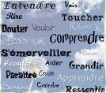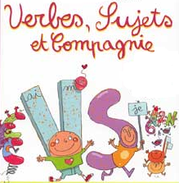

Contents

1. PRESENT TENSE 3
1.1 Present tense – regular 3
1.2 Present tense - Avoir expressions 3
1.3 Present tense – irregulars 4
1.4 Reflexive verbs 6
2. PERFECT 8
3. FUTURE 9
4. INFINITIVES 12
5. NEGATIVES 16
6. INTERROGATIVES 17
7. NOUNS 18
7.1 Masculine and feminine 18
7.2 Singular and plural 19
8. ADJECTIVES 20
8.1 Agreement 20
8.2 Irregular adjectives 21
8.3 Position of adjectives 21
8.4 Adjectives – comparatives and superlatives 21
8.5 Adjectives – possessives 22
9. ADVERBS 23
10. ARTICLES 24
10.1 Definite articles (le, la, les) 24
10.2 Indefinite articles (un, une, des) 25
10.3 Partitive articles (some, any) 25
11. PRONOUNS 26
11.1 Pronouns – subjects & reflexive 26
11.2 Pronouns – relative 26
11.3 Pronouns – direct object 27
12. PREPOSITIONS 28
13. CONJUNCTIONS 30
14. NUMBERS, DATES AND TIMES 30
15. QUANTITIES 33

1. PRESENT TENSE

1.1 Present tense – regular

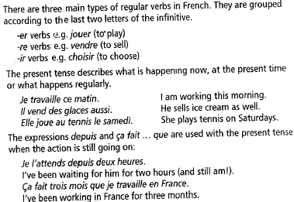

1.2 Present tense - Avoir expressions

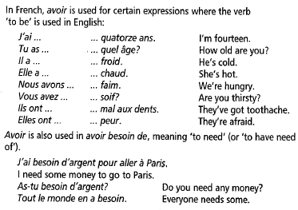

1.3 Present tense – irregulars

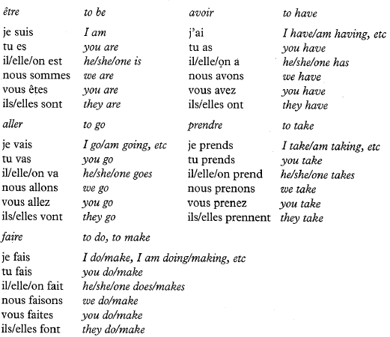

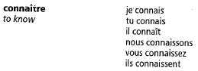 | 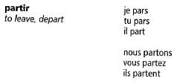
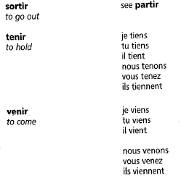 | 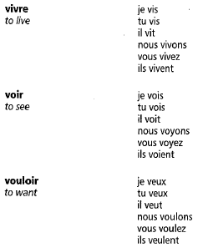
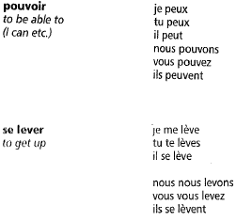 | 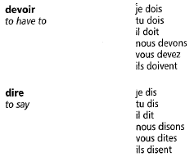

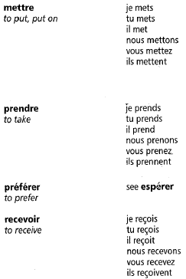 | 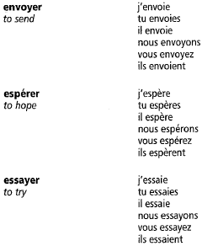

1.4 Reflexive verbs

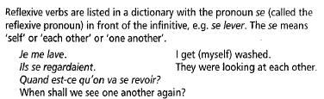

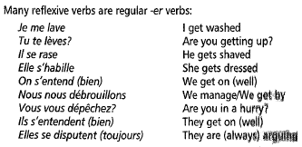

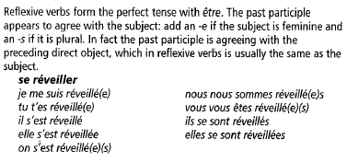

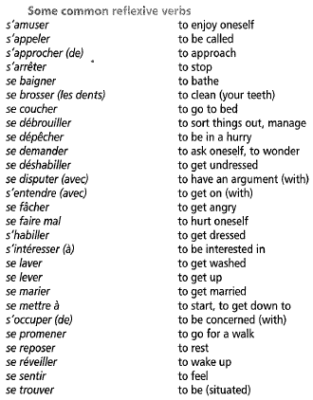

2. PERFECT

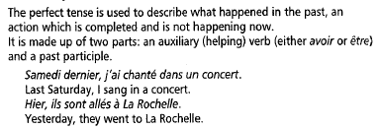

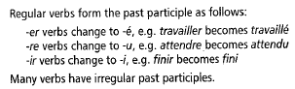

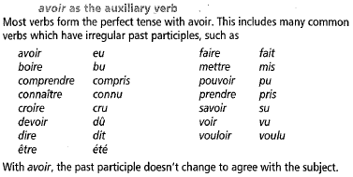

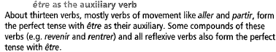

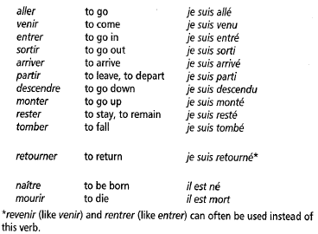

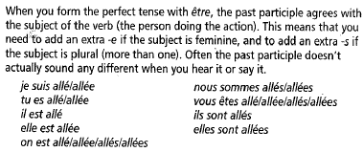

3. FUTURE

The near future

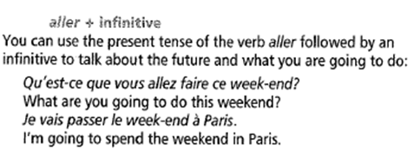

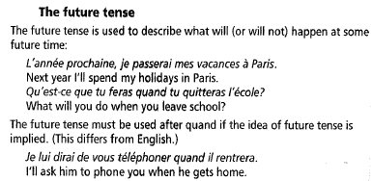

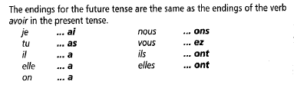

- regular –er and –ir verbs:

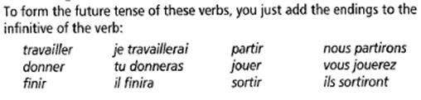

- regular –re verbs:

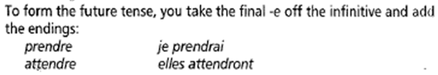

- irregular verbs:

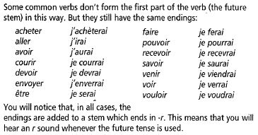

4. INFINITIVES

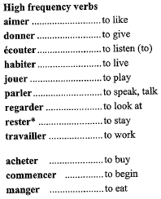  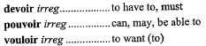 | 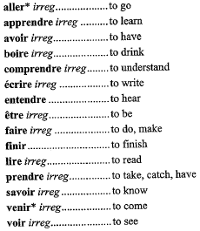
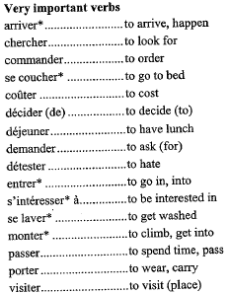 | 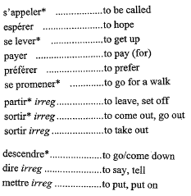

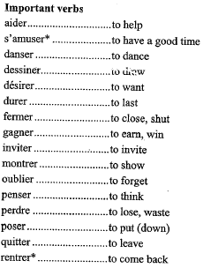 | 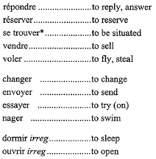
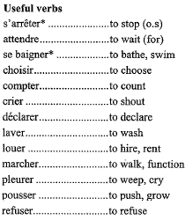 | 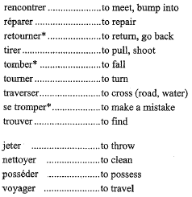

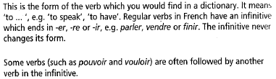
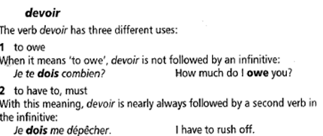

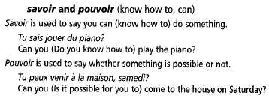

5. NEGATIVES
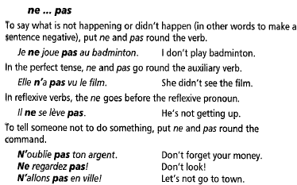

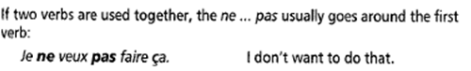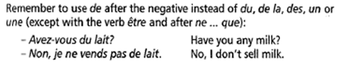

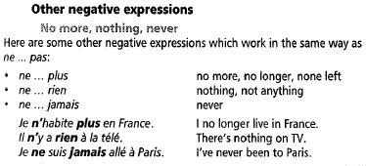

6. INTERROGATIVES

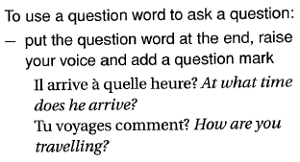
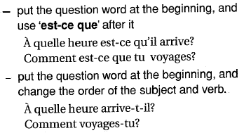

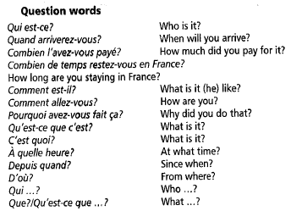

7. NOUNS

7.1 Masculine and feminine

A noun is the name of someone or something or the word for a thing (eg a box, a pencil, a laughter). All nouns in French are either masculine or feminine (this is called their gender).
Masculine singular feminine singular
Le garçon la fille
Un village une ville
L’appartement l’épicerie
Nouns which refer to people often have a special feminine form. Most follow one of these patterns:

 | masculine | Feminine
Add -e | Un ami | Une amie
-er -> ère | Une ouvrier | Une ouvrière
-eur -> -euse | Un vendeur | Une vendeuse
-eur -> -rice | Un instituteur | Une institutrice
-en -> -enne | Un lycéen | Une lycénne
Stay same | Un touriste  Un élève  Un enfant | Un touriste  Un élève  Un enfant
No pattern | Un copain | Une copine

Is it masculine or feminine?
Sometimes the ending of a word can give you a clue as to whether it’s masculine or feminine. Here are some guidelines:
endings  normally  masculine | exceptions
-age  -aire  -é  -eau  -eur  -ier  -in  -ing  -isme  -ment  -o | Une image  L’eau  La fin  La météo
endings  normally  feminine | exceptions
-ade  -ance  -ation  -ée  -erie  -ette  -que  -rice  -sse  -ure | Un lycée  Un squelette  Le plastique  Le dentifrice

7.2 Singular and plural
Nouns can also be singular (referring to just one thing or person) or plural (referring to more than one thing or person)
Une chambre des chambres

In many cases, it is easy to use and recognise plural nouns because the last letter is an –s. (remember that an –s on the end of a French word is often silent)
Un livre des livres

Some common exceptions:
- most nouns which end in –eau or –eu add an –x:
un château des châteaux
un jeu des jeux
- most nouns which end in –al change this to –aux in the plural
un animal des animaux
- nouns which already end in –s, -x or –z don’t change in the plural
un repas des repas
le prix les prix

8. ADJECTIVES

8.1 Agreement

Adjectives, or describing words (eg tall, important) tell you more about a noun. In French, adjectives are masculine, feminine, singular or plural to agree with the noun.
Look at the patterns in the tables below to see how adjectives agree.

Sing masc | Sing fem | Plural masc | Plural fem
grand | grande | grands | grandes

A lot of adjectives follow the above pattern

Ajectives which end in –u, -I, or –é change in spelling, but sound the same

bleu  joli  fatigué | bleue  jolie  fatiguée | bleus  jolis  fatigués | bleues  jolies  fatiguées

Adjectives which already end in –e (with no accent) have no different feminine form:

jaune | jaune | jaunes | jaunes

Adjectives which already end in –s have no different masculine plural form:

français | française | français | françaises

Adjectives which end in –er follow this pattern:

cher | chère | chers | chères

Adjectives which end in –eux follow this pattern:

délicieux | délicieuse | délicieux | délicieuses

Some adjectives double the last letter before adding an –e for the feminine form:
Gros  bon | grosse  bonne | gros  bons | grosses  bonnes

8.2 Irregular adjectives

Many common adjectives are irregular, and you need to learn each one separately. Here are some you have already met:
blanc  long  vieux (vieil)  nouveau (nouvel)  beau (bel) | blanche  longue  vieille  nouvelle  belle | blancs  longs  vieux  nouveaux  beaux | blanches  longues  vieilles  nouvelles  belles

Vieil, nouvel, bel are used before masculine nouns which begin with a vowel.

A few adjectives are invariable (inv.) and do not change at all:
marron
bleu marine
vert foncé
gris clair

8.3 Position of adjectives

Adjectives normally follow the noun
J’ai vu un film tres intéressant à la télé
Regarde cette jupe noire
Some common adjectives go before the noun e.g. grand, petit, bon, mauvais, beau, jeune, vieux, joli, gros, premier, court, long, haut
C’est un petit garcon
Il prend le premier train pour Paris

8.4 Adjectives – comparatives and superlatives

- comparisons

To compare one person or thing with another, you use plus (more), moins (less) or aussi (as) before the adjective, followed by que (than/as):
Plus riche que richer than
Il est moins riche que mon pere less rich than
aussi as rich as

Remember to make the adjective agree in the usual way:
Mattéo est plus âgé que Sarah
Sarah est plus âgée que Adam
Lucas et Noémie sont plus âgés que Jordan

Notice these special forms:
bon -> meilleur (better)
mauvais -> pire (worse)

Ce livre est meilleur que l’autre
Cet article est pire que l’autre

- The superlative
You use the superlative when you want to say something is the best, the biggest, the most expensive, etc.
La tour Eiffel est le plus célèbre monument de Paris
The Eiffel tower is the most famous monument in Paris
Paris est la plus belle ville du monde
Paris is the most beautiful city in the world
Les TGV sont les trains français les plus rapides
The TGV are the fastest French trains

Notice that:
-you use le plus, la plus, les plus and the correct form of the adjective, depending on whether you are describing something which is masculine, feminine or plural.
-you usually use le/la/les plus (meaning “the most”) but you can also use le/la/les moins (meaning “the least”):
J’ai acheté ce gâteau parce que c’était le moins cher
I bought this cake because it was the least expensive

8.5 Adjectives – possessives

 | singular |  |  | Plural  (all forms)
 | masculine | feminine | Before a vowel
my  your  his/her/its  our  your  their | mon  ton  son  notre  votre  leur | ma  ta  sa  notre  votre  leur | mon  ton  son  notre  votre  leur | mes  tes  ses  nos  vos  leurs

These words show who something or somebody belongs to. They agree with the noun that follows them, NOT the person.
This means that son, sa, ses can mean “his”, “her” or “its”. The meaning is usually clear from the context

Paul mange son déjeuner Paul eats his lunch
Marie mange son déjeuner Marie eats her lunch
Le chien mange son déjeuner the dog eats its lunch

Before a feminine noun beginning with a vowel, you can use mon, ton or son:

Mon amie s’appelle Nicole
Où habite ton amie?
Son école est fermée aujourd’hui.

9. ADVERBS

- adverbs usually tell you how, when or where something happened, or how often something is done.
Many adverbs in English end in –ly, e.g. quietly. Similarly, many adverbs in French end
in –ment, e.g. doucement.
To form an adverb in French you can often add –ment to the feminine singular of the adjective:

Masculine  sungular | Feminine  singular |  | Adverb
malheureux | malheureuse | + ment | malheureusement
lent | lente | + ment | lentement

If a masculine singular adjective ends in a vowel, just add –ment:
vrai + ment vraiment (= really, truly)

If a masculine singular adjective ends in –ent, change to –emment:
évident évidemment (=obviously)

Notice these special forms:
bien (well) mieux (better)
mal (badly) pire (worse)

Common adverbs

alors then  à l’heure on time  au début de at the start of  assez de enough of  l’année dernière last year  l’année prochaine next year  aujourd’hui today  autrefois in the past  aussi also, as well, too  aussitôt straight away  bientôt soon  demain tomorrow  dernièrement recently  d’abord first, first of all  déjà already  d’habitude usually  en ce moment now  en fait in fact  de temps en temps from time to time  en même temps at the same time  ensuite afterwards, next, then  environ about, roughly  encore again, still, yet  enfin at last, finally  ensemble together  finalement finally  généralement generally | heureusement fortunately  la semaine dernière last week  la semaine prochaine next week  lentement slowly  longtemps for a long time  parfois sometimes  hier (soir) yesterday (evening)  il y a deux jours two days ago  le lundi on Mondays  maintenant now  malheureusement unfortunately  normalement normally, usually  par exemple for example  pas du tout not at all  peut-être perhaps, maybe  puis then  quelquefois sometimes  toujours always  rapidement quickly  tout de suite straight away  vite quickly, fast  vraiment really  récemment recently  tous les jours every day

10. ARTICLES

10.1 Definite articles (le, la, les)

The definite article is the word for “the” which appears before a noun. It is often left out in English, but it must not be left out in French (except in a very few cases).

masculine | Singular  masculine | Before a vowel | Plural  (all forms)
Le village | La ville | L’épicerie | Les touristes

Main uses:

- to refer to a particular thing or person, in the same way as we use “the” in English:
Voici l’hôtel où nous sommes restés
There’s the hotel where we stayed
- to make general statements about likes and dislikes:
J’aime les pommes mais je n’aime pas les prunes
I like apples but I don’t like plums
- with parts of the body:
Il s’est brossé les dents He brushed his teeth
Elle a mal à la tête She has a headache
- with days of the week to give an idea of “every”:
je joue au tennis le samedi matin
I play tennis on Saturday mornings
- with different times of the day to mean “in” or “during”:
Le matin, j’ai cours de 9 heures jusqu’à midi et demi
In the morning, I have lessons from 9 o’clock until 12.30

10.2 Indefinite articles (un, une, des)

These are words for “a”, “an” or “some” in French
Singular  Masculine feminine | Plural  (all forms)
Un appartement une maison | Des appartements  Des maisons

No article is used in French when describing a person’s occupation:
Elle est dentiste She is a dentist

10.3 Partitive articles (some, any)

The word for “some” or “any” changes according to the noun it is used with:

Singular masculine | Singular feminine | Before  A vowel | Plural  (all forms)
du pain | de la viande | de l’eau | des poires

Use de (d’) instead of du/de la/de l’/des in the following cases:
- after a negative (ne…pas, ne…plus, ne…jamais, etc)
je n’ai pas d’argent I haven’t got any money
il n’y a plus de légumes There are no veg left
- after expressions of quantity:
Un kilo de poires a kilo of pears

11. PRONOUNS

11.1 Pronouns – subjects & reflexive

The subject of a verb is the person or thing performing the action or being described. In the sentence Jean regarde la télé, the subject is Jean because it is Jean who is watching TV.
Subject pronouns are pronouns like « I », « you », etc which usually come before the verb.
In French the subject pronouns are :
Je I
Tu you (to a young person, close friend or relative)
Il he, it
Elle she, it
On one, you, we (often used in place of nous in spoken French), they (people in general)
Nous we
Vous you (to an adult you don’t know well), you (to more than one person)
Ils they (masculine plural, or mixed group)
Elles they (feminine plural)

The reflexive pronouns are added after the subject pronoun with reflexive verbs. Reflexive verbs are written with « se » before the infinitive, e.g. se coucher
Je me couche nous nous couchons
Tu te couches vous vous couchez
Il/elle/on se couche ils/elles se couchent

11.2 Pronouns – relative

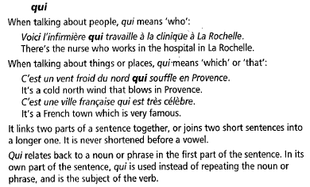

11.3 Pronouns – direct object

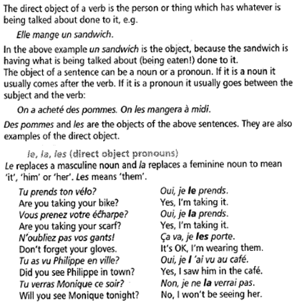

12. PREPOSITIONS

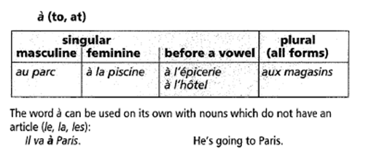
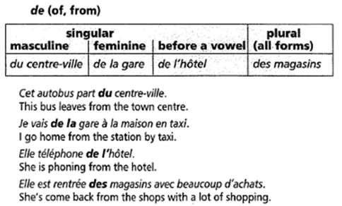
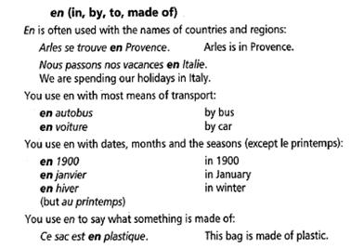
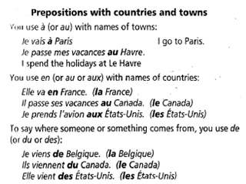

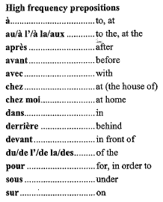 | 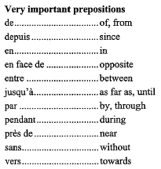
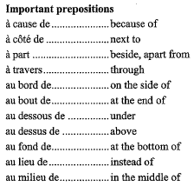 | 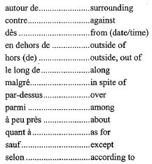

13. CONJUNCTIONS

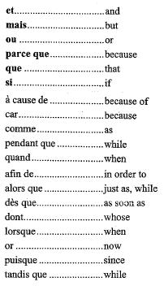 | 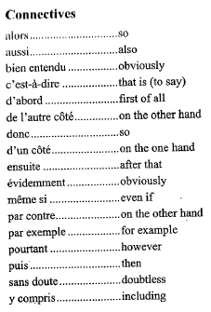

14. NUMBERS, DATES AND TIMES

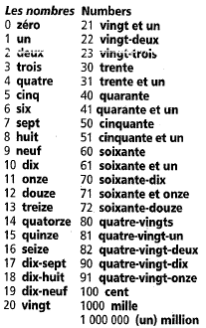 | 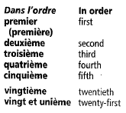

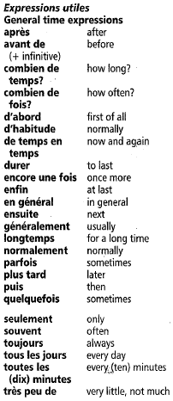 | 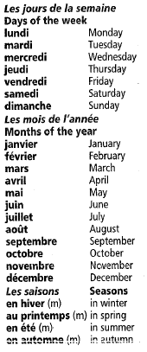
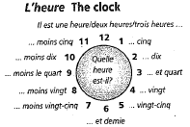 | 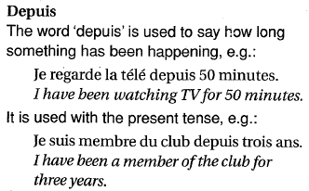

15. QUANTITIES

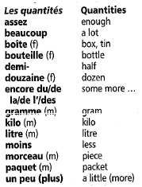 | 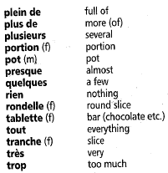
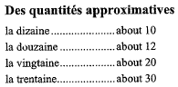 | 