LE PASSÉ COMPOSÉ

In French you use the perfect tense (le passé composé) to say what you have done at a certain time in the past.
The passé composé is usually formed by using the present tense of AVOIR and the past participle of the verb, just as in English.
J’ai joué = I have played

Auxiliary verb (AVOIR) past participle | Auxiliary verb (AVOIR) past participle
J’ai joué  Tu as joué  Il/elle a joué | Nous avons joué  Vous avez joué  Ils/elles ont joué

- To form the past participle of –er verbs, take the –er off the infinitive and replace it with –é.
Jouer -> joué

- Regular –ir verbs make their past participles by taking off the final –r :
Dormir -> dormi partir -> parti
Finir -> fini sortir -> sorti

- Regular –re verbs take off the –re and replace it with –u :

Répondre -> répondu

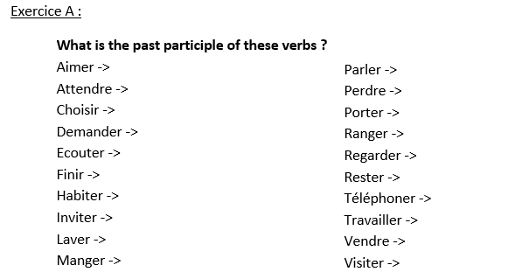
Past participles of IRREGULAR verbs
Avoir ->
(to drink) Boire ->
( to read) Lire ->
(to see) Voir ->
(to come) Venir ->
(to say) Dire ->
(to write) Ecrire ->
(to do) Faire->
(to take) Prendre ->
(to learn) Apprendre ->
(to understand) Comprendre ->
(to put) Mettre ->

Translation :
- I took the bus =
- He drank some water =
- We read some magazines =
- I learned spanish =
- Have you (plural) done your homework ? =
- He didn’t understand =
- Have you (singular) seen this film ? =
- She wrote a response to her letter =
- They (masc) went on a bike ride =
(faire une balade en vélo)
- I have put on my black trousers =
The perfect tense and negatives :
The negative words go around the auxiliary verb (AVOIR/ETRE)
Je n’ai pas fini = I haven’t finished
Je n’ai jamais fait de ski = I have never skied
Il n’a rien mangé = he hasn’t eaten anything
************************************************************************************
In the perfect tense most verbs take AVOIR but some take ETRE.
Je suis allé(e) = I went / I have been
Je suis | Nous sommes
Tu es | Vous êtes
Il/elle/on est | Ils/elles sont

With verbs which use être as the auxiliary verb, the past participle agrees with the subject, that means it takes an e if the subject is feminine and s if the subject is plural.
Exercice B :
- Tom _________ allé au collège
- Nicolas __________ allé au cinéma
- Patrice et Fabien ___________ allé___ à la piscine
- Ma sœur ___________ allé___ en ville
- Mes frères ___________ allé___ à la plage
- Je _____ allé en ville
- Où ______-tu allé ?
- Vous ________ allé chez Maurice
- Les filles __________ allé____ à la boum
- Paul et Sabine __________ allé____ à la gare

The following verbs form the passé composé with ETRE. MRS VAN DE TRAMP
Monter
Rester
Sortir

Venir
Arriver
Naitre

Descendre
Entrer

Tomber
Retourner
Aller
Mourir
Partir
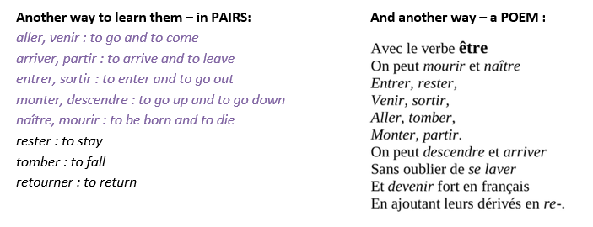
Exercice C:
- Je _____________________ à 8h (partir)
- Il _________________________ à 10h (partir)
- Elle ______________________ à 11h (partir)
- Tu _______________________ à midi (partir)
- Nous ______________________ à 16h (arriver)
- Vous ______________________ à 17h (arriver)
- Les filles ____________________ à 22h (arriver)
- Isabelle _____________________ à la maison (rester)
- Nicolas _____________________ dans la rue (tomber)
- Ses frères ___________________ avec lui (rester)
Reflexive verbs in the past tense :
All reflexive verbs take être in the perfect tense.
The past participle agrees with the subject

Se reposer = to relax
Je me suis reposé(e) | Nous nous sommes reposé(e)s
Tu t’es reposé(e) | Vous vous êtes reposé(e)s
Il/elle/on s’est reposé(e) | Ils/elles se sont reposé(e)s

Exercice D :
- Je ______________________________________ (se reposer = to relax, to rest)

- Nous ____________________________________ (se baigner = to to in the water)

- Ils ______________________________________ (se disputer = to argue )

- Vous ____________________________________(s’habiller = to get dressed)

- Elles ____________________________________ (s’amuser = to have fun)

- Tu ______________________________________ (se lever = to get up)

Useful expressions :
- Hier = yesterday
- La semaine dernière = last week
- Il y a 2 ans = 2 years ago
- Samedi dernier = last Saturday
- Pendant les dernières vacances = during the last holidays

To give an opinion about an event in the past :
- J’ai passé un bon moment = I had a good time
- Je me suis bien amusé(e) = I had fun
- Je me suis ennuyé(e) = I was bored
- C’était excitant = It was exciting
- C’était décevant = It was disappointing
- C’était une bonne expérience = It was a good experience
- J’ai beaucoup apprécié de faire ça = I liked doing that
- J’ai regretté d’avoir fait ça = I regretted doing that

