Introduction to verbs and subjects
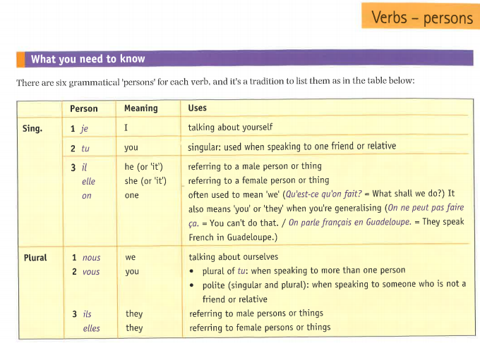
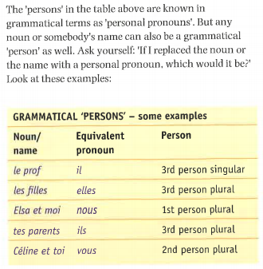
Note: Some words in French are regarded as singular when in English they would be plural.
A few examples:
La famille (= the family)
La classe (= the class)
La police (= the police)
Le personnel (=the staff)

When using those nouns as subjects, the verbs will be in the singular 3rd person

