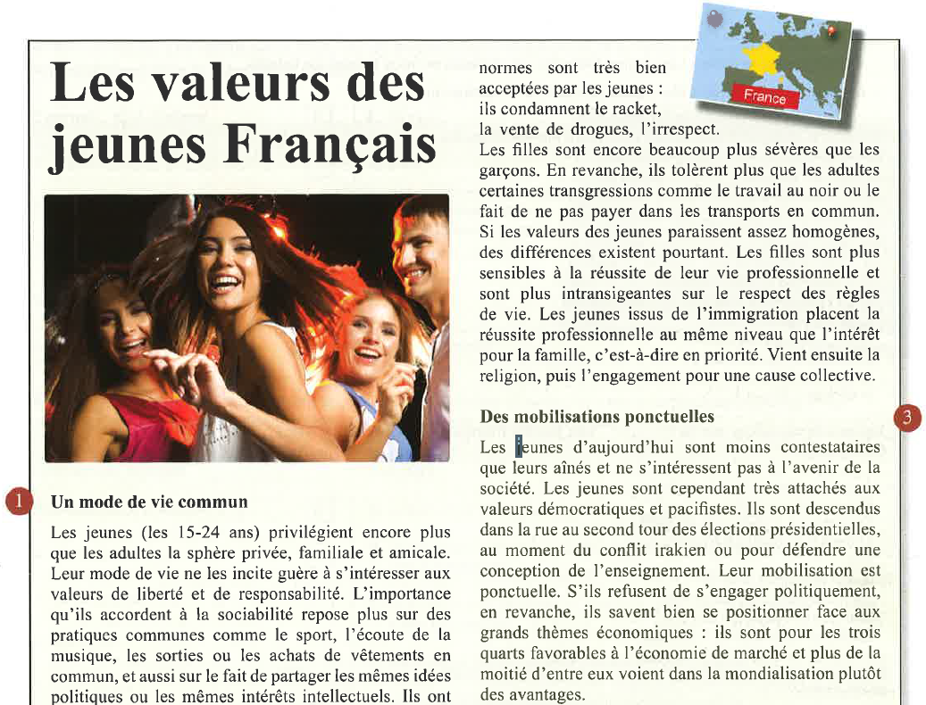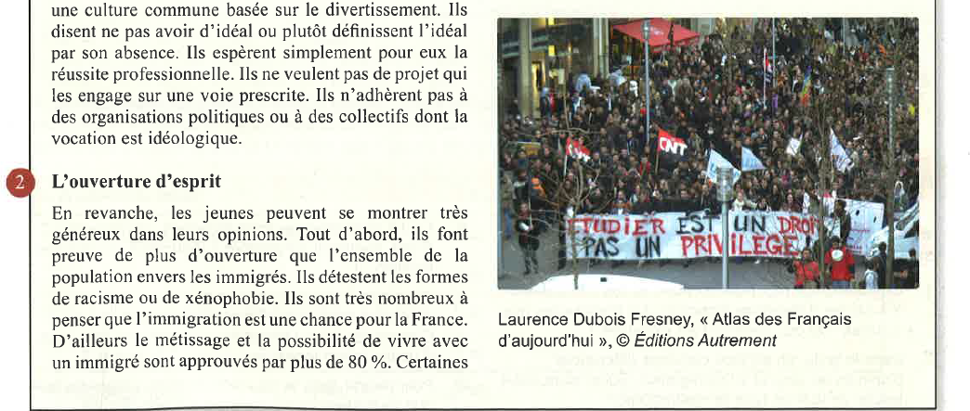

Source Le Monde en français
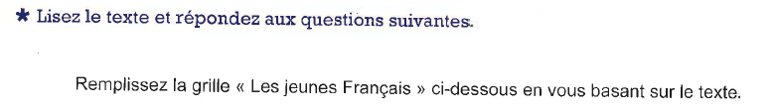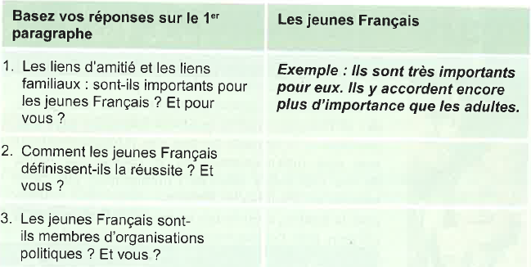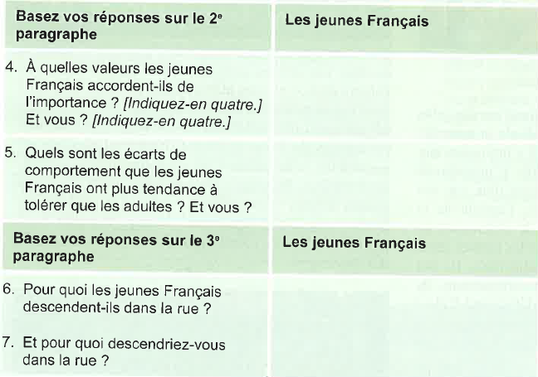

8. 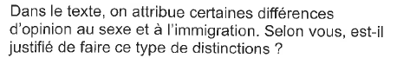
________________________________________________________________________________________________________________________________________________________________________________________________________________________________________________________________________________________________________________________________________
9. 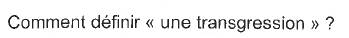
____________________________________________________________________________________________________________________________________________________________________

10.
____________________________________________________________________________________________________________________________________________________________________
11. 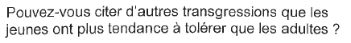
____________________________________________________________________________________________________________________________________________________________________
12. 


