**Récit de vacances 1:**

[](http://www.google.co.uk/imgres?q=elephant+cartoon#&hl=en&biw=1280&bih=595&tbm=isch&tbnid=2fD9YfGnQBSUIM:&imgrefurl=http://www.dreamstime.com/stock-photography-cartoon-elephant-image16516562&docid=oNRVYlf10URyBM&imgurl=http://thumbs.dreamstime.com/z/cartoon-elephant-16516562.jpg&w=800&h=850&ei=0QolUvGGKZKa0AWTsIAI&zoom=1&ved=1t:3588,r:26,s:0,i:178&iact=rc&page=2&tbnh=185&tbnw=179&start=12&ndsp=18&tx=107&ty=70) [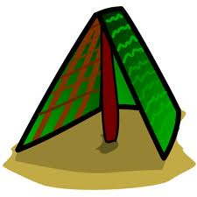](http://www.google.co.uk/url?sa=i&rct=j&q=tent%20cartoon&source=images&cd=&cad=rja&docid=uYHdlU2iMHkYzM&tbnid=3r21dLlK_QIugM:&ved=0CAUQjRw&url=http://tuxpaint.org/stamps/index.php3?cat=town&perpage=50&ei=fwwlUqOrCcvw0gXq5oGwCQ&psig=AFQjCNGBVsJbiMCS7juVVUyI1owAxM5ZKA&ust=1378246110869382) [](http://www.google.co.uk/url?sa=i&rct=j&q=passport%20cartoon&source=images&cd=&cad=rja&docid=9BfR8ICp3Zh51M&tbnid=7BqkIeSJqhUHpM:&ved=0CAUQjRw&url=http://acclaimclipart.com/free_clipart_images/passport_booklet_0515-0910-0102-4733.html&ei=vgwlUqeuBMaK0AXYmoGADw&psig=AFQjCNGqQoA4x7PlHoq5bpoDch1CHBkkqQ&ust=1378246176652651)

[](http://www.google.co.uk/url?sa=i&rct=j&q=doctor%20cartoon&source=images&cd=&cad=rja&docid=LHFV8VkrofKAWM&tbnid=kXcurZ5wE0kz4M:&ved=0CAUQjRw&url=http://www.toonvectors.com/clip-art/cartoon-doctor-man-waving/19026&ei=Fw0lUoXQKIWx0QXU5oDYCg&psig=AFQjCNEnhVi_Kp5FfLinA17fhELwWfZMoQ&ust=1378246249874860)[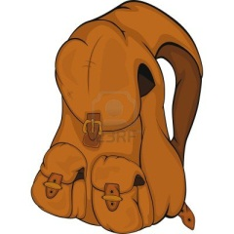](http://www.google.co.uk/url?sa=i&rct=j&q=back%20pack%20cartoon&source=images&cd=&cad=rja&docid=3un0yR5LU-9mhM&tbnid=t3Dx33eU3ITsvM:&ved=0CAUQjRw&url=http://www.123rf.com/photo_12486627_school-backpack-cartoon.html&ei=bQ4lUpWCDuX30gWT5YGICQ&psig=AFQjCNFGym7gR7gsnaUgPOUfaRFR347lXA&ust=1378246625202762)

**Récit de vacances 2:**

[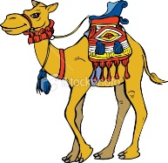](http://www.google.co.uk/url?sa=i&rct=j&q=camel%20cartoon#&source=images&cd=&cad=rja&docid=dM8ggIYd7XA-IM&tbnid=dfk7vmSdgJ-rRM:&ved=0CAUQjRw&url=http://vector-magz.com/cartoons/camel-cartoon-item-1/&ei=IgslUqS8JOid0AXTtICYBw&bvm=bv.51495398,d.d2k&psig=AFQjCNHdbsWsKTBByZNUTEEfr4c82OSKYQ&ust=1378245760772396)[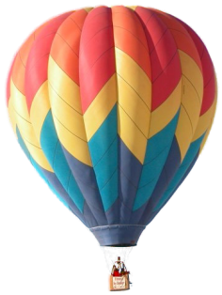](http://www.google.co.uk/url?sa=i&rct=j&q=hot%20air%20balloon%20cartoon&source=images&cd=&cad=rja&docid=ULpdTtdIKoDxPM&tbnid=PZ41SfOk1KMu0M:&ved=0CAUQjRw&url=http://wakpaper.com/id114611/hot-air-balloon-cartoon-pictures-360x480-pixel.html&ei=1g4lUvz0Ma620QXfpIHwBA&psig=AFQjCNFdhDjxPVCa9NZCl0Yorkc6tQ6Wow&ust=1378246674488430)[](http://www.google.co.uk/url?sa=i&rct=j&q=key%20cartoon&source=images&cd=&cad=rja&docid=WDAkp1n71qDyzM&tbnid=4RZ26BBkxhZAjM:&ved=0CAUQjRw&url=http://www.shutterstock.com/pic-72569716/stock-vector-key-cartoon.html&ei=VQ8lUvrTK-mw0AXLoYDAAw&psig=AFQjCNF8FhoZePFP0xa1L_qKySf_tXVpOw&ust=1378246796496665)

[](http://www.google.co.uk/url?sa=i&rct=j&q=map%20cartoon&source=images&cd=&cad=rja&docid=Lly24N50E9BUGM&tbnid=Fzn4wdcVALo5VM:&ved=0CAUQjRw&url=http://itsadeliverything.com/a-clear-vision-is-essential-for-agile-programme-management/cartoon-map-folded&ei=mw8lUr6OJ5H60gXe24D4Aw&psig=AFQjCNG78O7OPpVKujKwRjXQnN6f4TOCNQ&ust=1378246900563520) [](http://www.google.co.uk/url?sa=i&rct=j&q=policeman%20cartoon&source=images&cd=&cad=rja&docid=VNNlUJnb6X1AJM&tbnid=71doKbyIbZxXaM:&ved=0CAUQjRw&url=http://madronaseattle.com/&ei=-Q8lUs_SIeKS1AWjvIDQCg&psig=AFQjCNE6mQ9FXZiNa27eV4sIo6IEXISsfw&ust=1378246979300389)

**Récit de vacances 3:**

[](http://www.google.co.uk/imgres?imgurl&imgrefurl=http://www.dragoart.com/tuts/2605/1/1/how-to-draw-a-cartoon-jellyfish.htm&h=0&w=0&sz=1&tbnid=fa9ejEoso-DL7M&tbnh=250&tbnw=202&prev=/search?q=iguana+cartoon#&tbm=isch&tbo=u&zoom=1&q=iguana cartoon#&docid=SwldR-yaJUHelM&hl=en&ei=hwslUoWaLcyU0QX-6IGwBQ&ved=0CAEQsCU) [](http://www.google.co.uk/imgres?q=desert+island+cartoon&hl=en&biw=1280&bih=595&tbm=isch&tbnid=2T_jcEoIL9xemM:&imgrefurl=http://www.istockphoto.com/stock-illustration-10082405-cartoon-tropical-island.php&docid=t4BX62nVdt7-YM&imgurl=http://i.istockimg.com/file_thumbview_approve/10082405/2/stock-illustration-10082405-cartoon-tropical-island.jpg&w=371&h=380&ei=GwwlUqTuOunW0QWjuoDoDQ&zoom=1&ved=1t:3588,r:34,s:0,i:193&iact=rc&page=2&tbnh=189&tbnw=185&start=13&ndsp=24&tx=98&ty=106) [](http://www.google.co.uk/url?sa=i&rct=j&q=flag%20cartoon&source=images&cd=&cad=rja&docid=Om6PFFiDstFeKM&tbnid=mAYFbEaAOd7jNM:&ved=0CAUQjRw&url=http://www.shutterstock.com/pic-108430916/stock-photo-cartoon-flag.html&ei=2xAlUpX0G4em0AWb_ICQBQ&psig=AFQjCNHBPsZ6ra56wjw8aE1dlw4Zr0-CTA&ust=1378247198468970)

[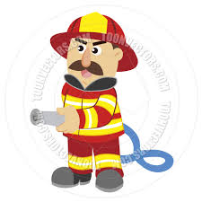](http://www.google.co.uk/imgres?q=fireman+cartoon&hl=en&biw=1280&bih=595&tbm=isch&tbnid=33xOkqZDG6QtCM:&imgrefurl=http://www.toonvectors.com/clip-art/cartoon-fireman-holding-firehose/36906&docid=75YltVeZavT2TM&imgurl=http://cdn.toonvectors.com/images/89/36906/toonvectors-36906-940.jpg&w=940&h=940&ei=EhElUtGSFou00QW3m4HoCg&zoom=1&ved=1t:3588,r:44,s:0,i:229&iact=rc&page=3&tbnh=178&tbnw=152&start=34&ndsp=21&tx=84&ty=88) [](http://www.google.co.uk/url?sa=i&rct=j&q=hippies%20camper%20van%20cartoon&source=images&cd=&cad=rja&docid=TH1bZBWCkdmSQM&tbnid=5o1zgociyXDaXM:&ved=0CAUQjRw&url=http://www.clker.com/clipart-pink-camper-van.html&ei=BxIlUrufDeam0AXJq4HADw&psig=AFQjCNHH3lc7rO4YGN_u8VDtfZE4MYG1SQ&ust=1378247543676095)

**Récit de vacances 4:**

[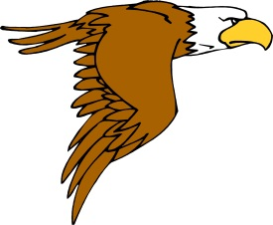](http://www.google.co.uk/url?sa=i&source=images&cd=&cad=rja&docid=1TVFBlAH7TEsBM&tbnid=vO7x656W8lQgxM:&ved=0CAgQjRwwAA&url=http://www.search-best-cartoon.com/cartoon-eagle-page-3.html&ei=ywslUq-aJsax0QX734CACw&psig=AFQjCNHUa09t4Vq-05fIc3e6Z-_X5VJv_Q&ust=1378245963666728) [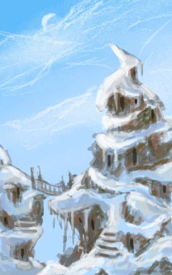](http://www.google.co.uk/url?sa=i&rct=j&q=snowy%20mountain%20top%20cartoon&source=images&cd=&cad=rja&docid=gc_nbPN26yh__M&tbnid=v5hIF7Vw0M6TMM:&ved=0CAUQjRw&url=http://www.conceptart.org/forums/showthread.php?t=144855&ei=8BMlUuHMBs6T0AWjwICwDA&psig=AFQjCNEuFn9Kxk7SlzChFu71ne05jT0G7w&ust=1378247625734958) [](http://www.google.co.uk/url?sa=i&rct=j&q=chef%20cartoon&source=images&cd=&cad=rja&docid=8FeaI6lDWtCY5M&tbnid=xg2QALdjyv8qkM:&ved=0CAUQjRw&url=http://www.dreamstime.com/royalty-free-stock-photography-happy-chef-cartoon-image25901927&ei=WhQlUsiXFMON0AW7i4GoDA&psig=AFQjCNG_bMMrhYemc36MPROfW0grGeCJ2Q&ust=1378248102864242)

[](http://www.google.co.uk/url?sa=i&rct=j&q=money%20cartoon&source=images&cd=&cad=rja&docid=jAKIhsfGx9AFkM&tbnid=tDpsw9m5DawN7M:&ved=0CAUQjRw&url=http://www.getvector.info/cartoon-vector-illustration-of-money-coins/&ei=RBclUqrWO4Xv0gXSr4G4Dw&psig=AFQjCNHm6XS57mwyspJNmSxNWJCGOB40CQ&ust=1378248874229737) [](http://www.google.co.uk/imgres?q=dog+cartoon&hl=en&biw=1280&bih=595&tbm=isch&tbnid=gq_NIZk7YSe2kM:&imgrefurl=http://cartoons-picture.blogspot.com/2012/12/cartoon-pictures-of-dogs-and-cats.html&docid=pCEGtiJos6cyWM&imgurl=http://howtocleancar.info/wp-content/uploads/cartoons/cartoon_pictures_of_dogs_and_catshow_to_draw_dogs_250x240.jpg-b564dfc4fe40b495566bb950b59ecdf8.gif&w=250&h=240&ei=bxclUquTLLOy0AX5yoDIDA&zoom=1&ved=1t:3588,r:55,s:0,i:262&iact=rc&page=4&tbnh=183&tbnw=191&start=51&ndsp=18&tx=97&ty=91)