PRONOUNS

- Pronouns – subjects & reflexive
The subject of a verb is the person or thing performing the action or being described. In the sentence Jean regarde la télé, the subject is Jean because it is Jean who is watching TV.

Subject pronouns are pronouns like « I », « you », etc which usually come before the verb.
In French the subject pronouns are :
Je I
Tu you (to a young person, close friend or relative)
Il he, it
Elle she, it
On one, you, we (often used in place of nous in spoken French), they (people in general)
Nous we
Vous you (to an adult you don’t know well), you (to more than one person)
Ils they (masculine plural, or mixed group)
Elles they (feminine plural)

The reflexive pronouns are added after the subject pronoun with reflexive verbs. Reflexive verbs are written with « se » before the infinitive, e.g. se coucher
Je me couche nous nous couchons
Tu te couches vous vous couchez
Il/elle/on se couche ils/elles se couchent

- Pronouns – relative
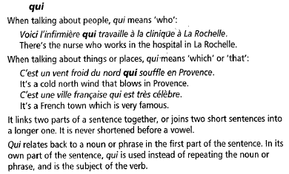
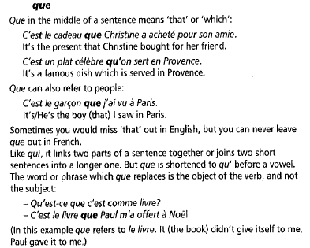

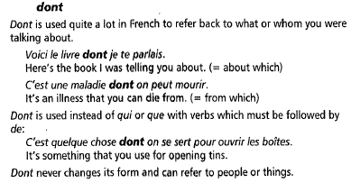

- Pronouns – demonstrative

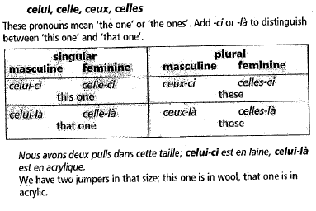

- Pronouns - Possessive
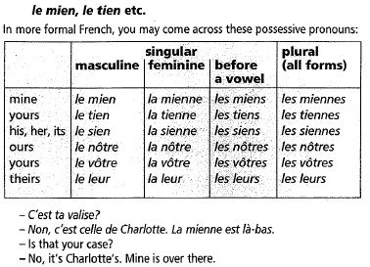

- Pronouns – direct & indirect object

- Direct object
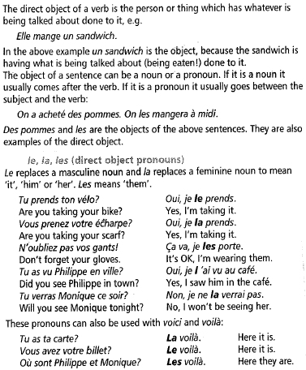

- Direct object pronoun in the perfect tense
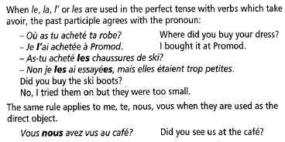

- Indirect object
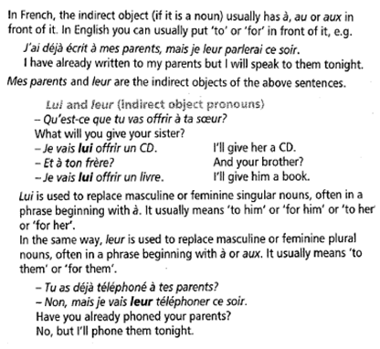

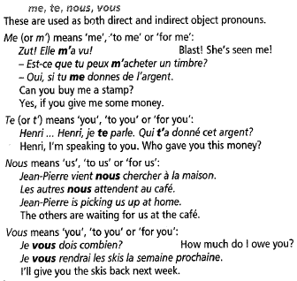

- Pronouns : position & order

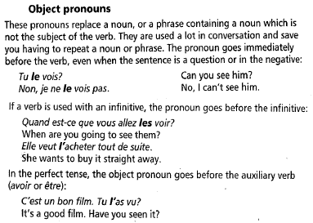
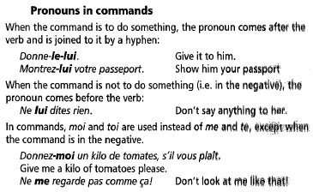

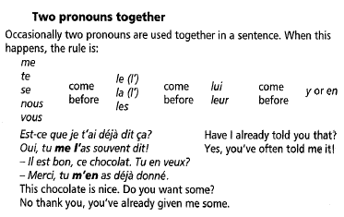

- Disjunctive & emphatic pronouns

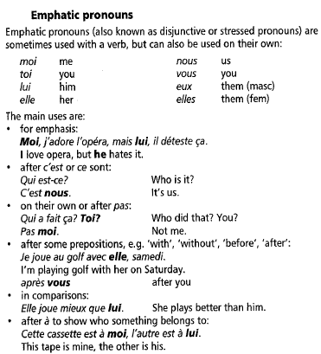

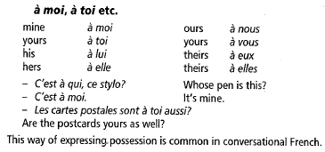

- Pronouns – indefinite
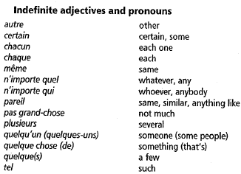

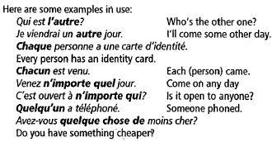

- Pronouns – y and en
