GRAMMAR PRACTICE – PERFECT TENSE OF REGULAR VERBS WITH AVOIR

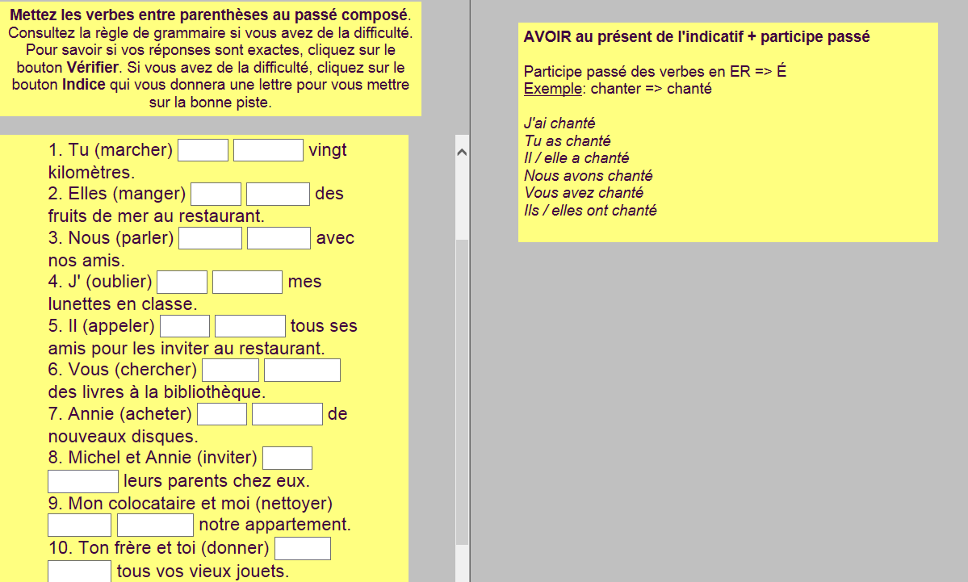

Vocab notes:

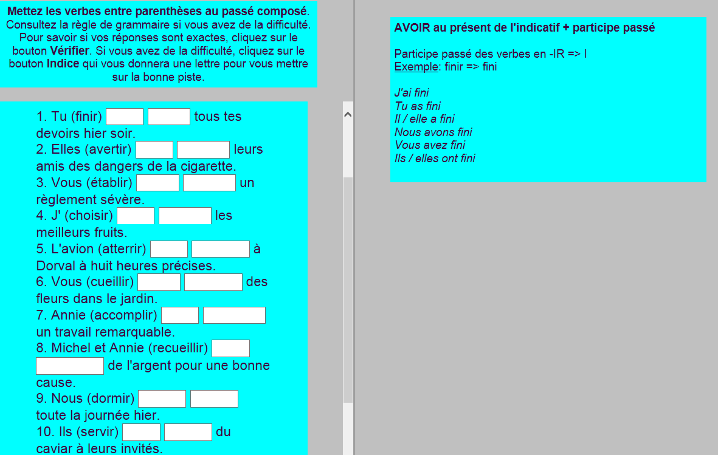

Vocab notes:

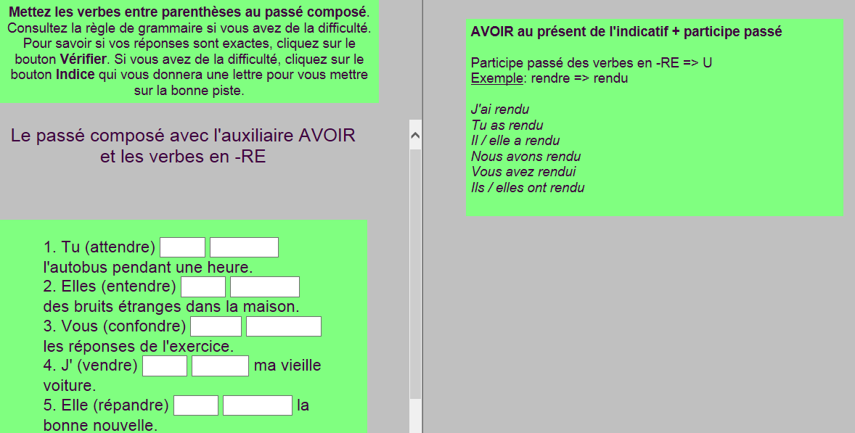

Vocab notes:

