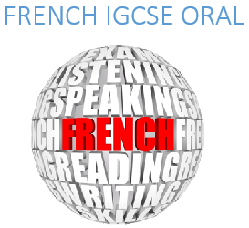
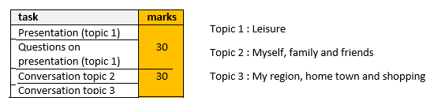
Examples of Presentations:
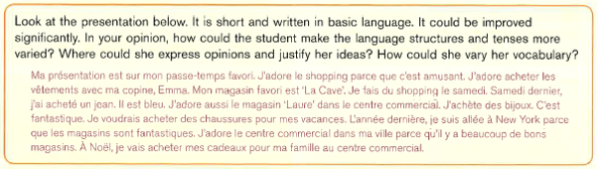
Dans mon temps libre, je fais de la photographie. Quand j'étais plus jeune, je n'aimais pas la photographie. Je pensais que c'était ennuyeux. J’aime ça parce qu’on peut explorer de nouveaux endroits. Mon type préféré de photographie est la photographie urbaine. Plus tard, je veux apprendre à éditer mes photos. J'aimerais aussi apprendre à filmer une vidéo en ralenti et ce serait bien si je pouvais vendre mes photos. Pourtant, je ne pense pas que les gens les achèteraient. J'ai l'intention de faire un voyage avec ma famille et je vais prendre des photos pour l'album de famille. J'apprécie vraiment la photographie et j'espère m’améliorer à l'avenir.
(110 words)
PRESENTATION: MES LOISIRS
No more than 200 words
What you could talk about (you won’t be able to mention everything – choose some points):
- Your favourite leisure activity (When and why you started it, who you do this activity with, where and when, your teacher/coach, your equipment, whether you will carry on in the future, whether you do competitions or performances or attend events, etc.)
- What you do in the Boarding House to relax
- What you do at home to relax
- What you did with your family / siblings last holidays for leisure
- Any clubs you are part of
- Some leisure activity you used to do in the past but don’t do anymore (and why)
- Some activity you would like to try in the future and why
- What leisure activities you would do if you had a lot of money
- Books you like reading, music you like listening to, films/programs/series you like watching
- The place of technology in your leisure (phones, tablets, computers)
- How you spend your pocket money on leisure activities

General Advice – Use this as a TICK LIST!
- DO NOT use a translator. You will have to learn your presentation by heart. It will be much easier for you to learn it if it is the product of your brain, not that of a computer. You can look up vocab, but put the sentences together yourself. I will correct your mistakes.
- For everything, give opinions, and a different one each time.
- Use a variety of verbs (count how many times you have used the over-used AVOIR / ETRE / FAIRE / ALLER / AIMER / IL Y A)
- Use PAST, PRESENT, FUTURE
- Use “I” and “we” forms
- Justify using “parce que” and “car”
- Use comparatives (plus…que ; moins… que)
- Use a sentence starting with “Si…”
- Connect sentences together with quand, où, mais, qui , que
- Use modal verbs (pouvoir, devoir, vouloir)
- Use time expressions: avant, après, pendant, tous les jours
- Banned words: intéressant / bien / ennuyeux / amusant / aimer (more than once) / aller (more than twice) / faire (more than twice) – you will have to use synonyms!
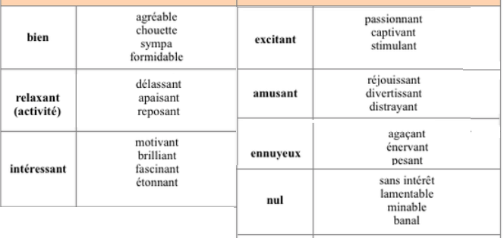
_______________________________________________________________________________________________________________________________________________________________________________________________________________________________________________________________________________________________________________________________________________________________________________________________________________________________________________________________________________________________________________________________________________________________________________________________________________________________________________________________________________________________________________________________________________________________________________________________________________________________________________________________________________________________________________________________________________________________________________________________________________________________________________________________________________________________________________________________________________________________________________________________________________________________________________________________________________________________________________________________________________________________________________________________________________________________________________________________________________________________________________________________________________________________________________________________________________________________________________________________________________________________________________________________________________________________________________________________________________________________________________________________________________________________________________________________________________________________________________________________________________________________________________________________________________________________________________________________________________________________________________________________________________________________________________________________________________________________________________________________________________________________________________________________________________________________________________________________________________________________________________________________________________________________________________________________________________

PAST (Imperfect)
Negative (ne…pas)
Je pensais que… = complex verb to introduce an opinion
justification
Modal verb (pouvoir)
specific vocabulary
Modal verb (vouloir)
Specific vocabulary
Specific vocabulary
CONDITIONAL
Structure with si
Connective (pourtant = however)
Object pronouns (les achèteraient = would buy them)
Je vais prendre = FUTURE
Adverb
J’espère m’améliorer (I hope to improve) = Complex verbs

